Resolving Merge Conflicts

Tasks:

1.Create a working directory and initiate git init

Command: mkdir, cd, git init

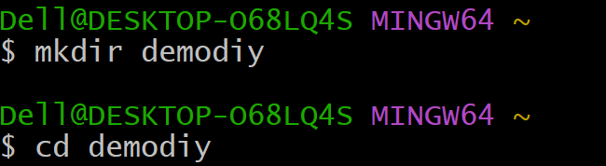

2.Start a new feature branch

Command: git branch feature

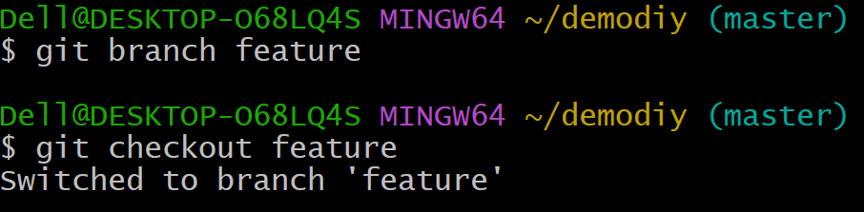

3.Create new files and commit file

Command : touch , git add, Git commit

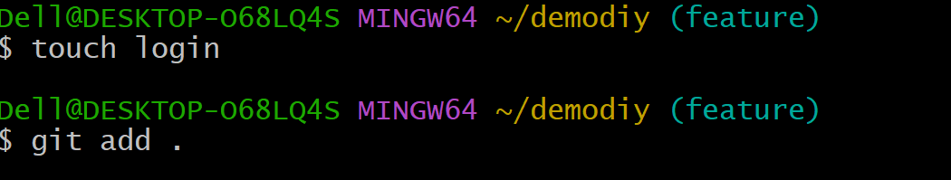

4.Now switch to the master branch and create a file with the name as

login and add some content and commit the changes

Command: git checkout master, touch login, git add,

,git commit

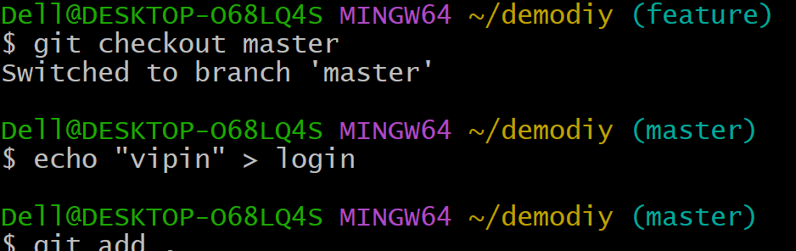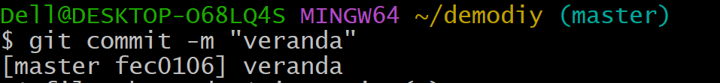

5.Switch to the feature branch and create a file with the same name login and add different content and commit the changes.

Command : git checkout feature,touch login,git add, ,git commit –m

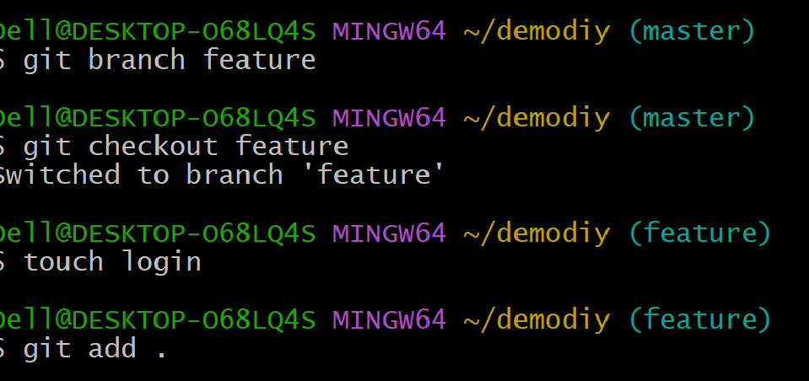

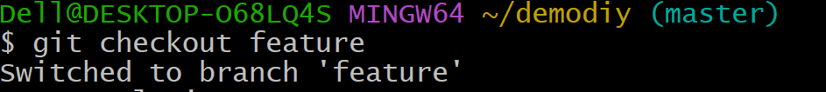

6.Both the branches should have the same file name but different

content.



7.Now merge the master branch to the feature branch

Command : git merge master feature



8.You will get merge conflicts

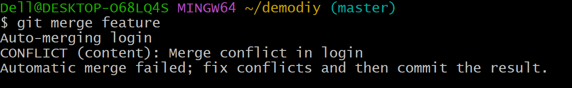

9.Execute the steps to resolve merge conflict

